Assignment 2 – Vaishnavi Vinayak Sawant - Letupgrade

Project 3

1. Linux1 Instance

Public Ip – 3.22.235.233

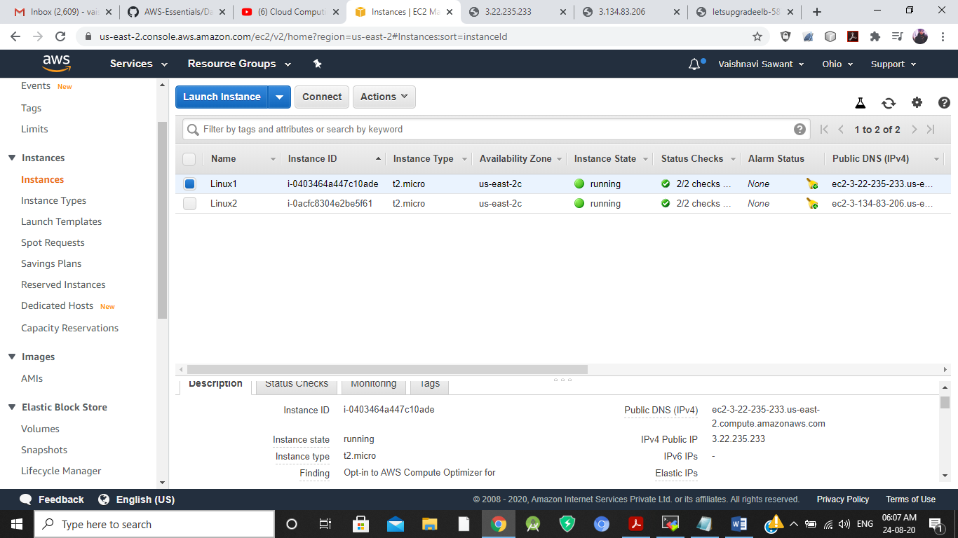

Linux1 Browser

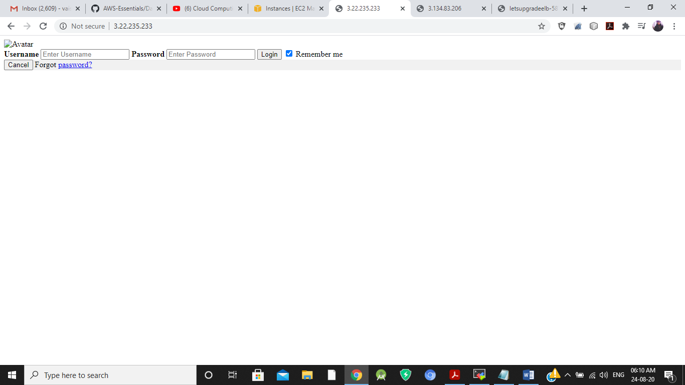

1. Linux2 Instance

Public Ip –

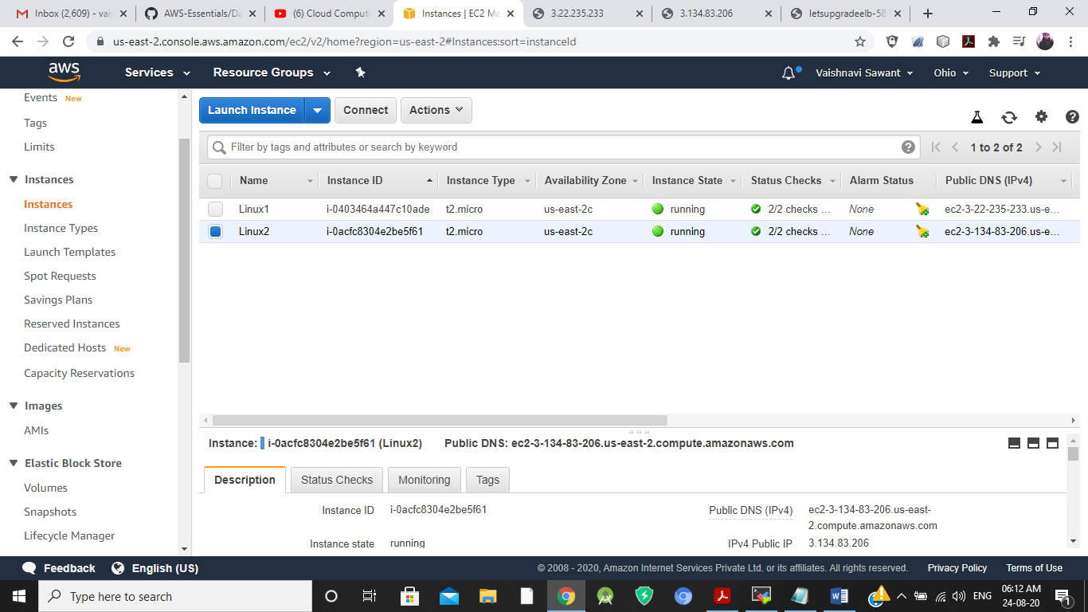

Linux2 Browser

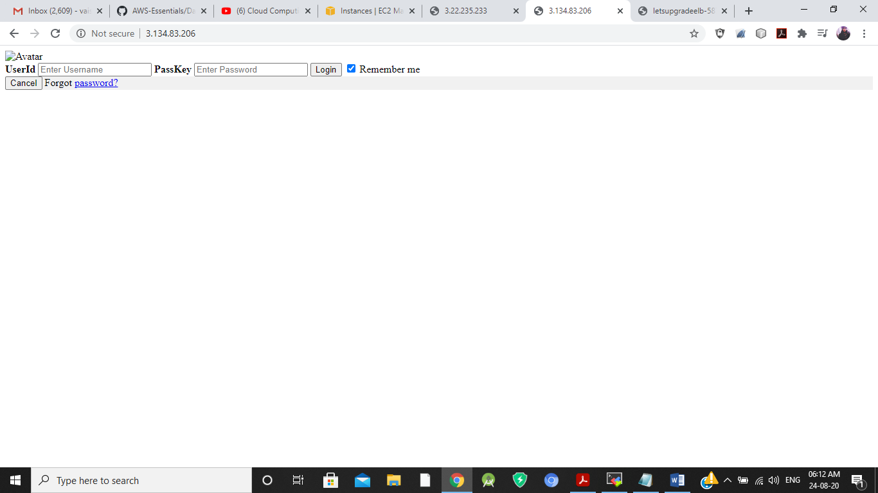

1. Load Balancer

DNS –

Letsupgradeelb-587122676.us-east2.elb.amazonaws.com

